Grade 6 ELA
Year-at-a Glance (Draft)
2024-2025

Module A  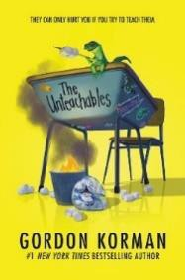  August 12-September 13  24 Days | Relating to Characters’ Troubles and Triumphs  Essential Question: How can a person’s decisions and actions change their life and the lives of others?  Anchor Text: The Unteachables  Writing Focus: Personal Narrative, Shared Experience Writing (Narrative) | Focus Benchmarks  ELA.6.R.1.1  ELA.6.R.1.2  ELA.6.R.1.3  ELA.6.R.3.1  ELA.6.C.1.2
Module B  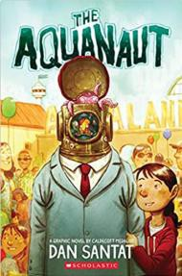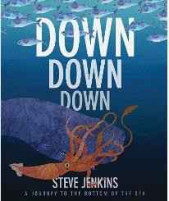  September 16-October 11  19 Days | Discovering the Magic of Marine Life  Essential Question: How can humans participate in protecting marine life and their environments?  Anchor Texts: The Aquanaut, Down, Down, Down: A Journey to the Bottom of the Sea BEST, Marine Life Communication Text Set  Writing Focus: Expository & Argumentative | Focus Benchmarks  ELA.6.R.1.1  ELA.6.R.1.3  ELA.6.R.2.2  ELA.6.R.2.3  ELA.6.R.2.4  ELA.6.R.3.4  ELA.6.C.1.3  ELA.6.C.1.4
Module C    October 15-November 8  19 Days | Analyzing Athletes in Action  Essential Question: How have sports influenced individuals and communities?  Anchor Texts: “Why Being a Sports Fan is Good for You” Sonnet, “We Are the Champions”, “Shakespearian Baseball Sonnet #98”, Excerpt from I Never Had it Made: An Autobiography of Jackie Robinson StudySync, Athletes’ Impact Text Set, “Amigo Brothers” StudySync, “We’re on the Same Team” StudySync, “The Voice in My Head” StudySync, Middle School Sports Text Set  Writing Focus: Expository  DISTRICT WRITING ASSESSMENT – Week of November 4 | Focus Benchmarks  ELA.6.R.1.2  ELA.6.R.1.4  ELA.6.R.2.1  ELA.6.R.2.2  ELA.6.R.2.3  ELA.6.R.2.4  ELA.6.R.3.1  ELA.6.R.3.4  ELA.6.C.1.2
Module D    November 11-December 20  24 Days | Comparing Characters’ Quests (Book Clubs/Literature Circles)  Essential Question: How are imaginative stories reinvented over time to teach readers lessons about real life?  Anchor Texts: Excerpt from The Lightning Thief; Heroes Every Child Should Know: Perseus StudySync, “Comparing and Contrasting Across Time Periods” StudySync, Excerpt from Tristan Strong Punches a Hole in the Sky, “The Waking,” “Courage, A Newcomer”, “The Quest for the Enchanted Stone”, Book Clubs TBD  Writing Focus: Expository; Quest Narratives | Focus Benchmarks  ELA.6.R.1.1  ELA.6.R.1.2  ELA.6.R.1.3  ELA.6.R.1.4  ELA.6.R.2.1  ELA.6.R.3.1  ELA.6.R.3.3  ELA.6.C.1.2  ELA.6.C.1.4
Module E  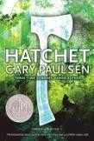  January 7 – February 7  23 Days | Surviving Life’s Unexpected Challenges  Essential Question: What traits, tools, and basic needs are necessary to survive in extreme conditions?  Anchor Texts: Hatchet BEST, “Lessons from Failure: Why  We Try, Try Again”, “Sonnet” by John Clare, Nature Effect Text Set  Writing Focus: Expository | Focus Benchmarks  ELA.6.R.1.1  ELA.6.R.1.2  ELA.6.R.1.4  ELA.6.R.2.2  ELA.6.R.2.3  ELA.6.R.3.1  ELA.6.C.1.4
Module F  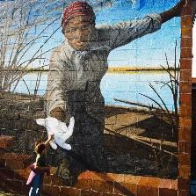  February 10 – March 14  24 Days | Exploring Art Forms & Their Impact  EQ: How does art significantly and positively impact local and global communities?  Anchor Texts: “Looking at Art Can Help Your Brain”  “Building a Better Brain Through Music, Dance, and Poetry”, “The Magic Marker Mystery” StudySync, Excerpt from Harriet Tubman: Conductor on the Underground Railroad BEST, “Letter to Harriet Tubman”, “An Eye for Art: Jacob Lawrence”, “The Past, Present, & Future of Street Art, Magnificent Murals”, “Bronx Masquerade” Study Sync, “The Treasure of Lemon Brown” StudySync, Technology & Art Text Set  Writing Focus: Expository & Argumentative | Focus Benchmarks  ELA.6.R.1.1  ELA.6.R.1.2  ELA.6.R.1.3  ELA.6.R.2.1  ELA.6.R.2.2  ELA.6.R.2.3  ELA.6.R.3.1  ELA.6.R.3.3  ELA.6.R.3.4  ELA.6.C.1.3  ELA.6.C.1.4
Module G  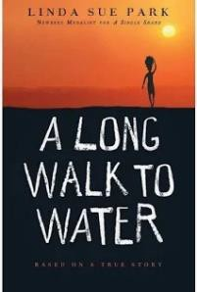  March 24 – April 25  23 Days | Walking with Others  Essential Question: Why is it important to learn about people, places, and issues within our community and around the world?  Anchor Texts: A Long Walk to Water BEST, “A Beacon of Hope…” StudySync, “Shree Bose: Never Too Young to Change the World” StudySync, “Malala Yousafzai-Nobel Lecture” StudySync, “The House on the Hill” BEST, “At Fourteen”, Excerpt from Ted Talk: “What Adults Can Learn from Children”  Writing Focus: Expository & Argumentative | Focus Benchmarks  ELA.6.R.1.1  ELA.6.R.1.2  ELA.6.R.1.3  ELA.6.R.1.4  ELA.6.R.2.1  ELA.6.R.2.2  ELA.6.R.2.3  ELA.6.R.2.4  ELA.6.R.3.1  ELA.6.R.3.3  ELA.6.R.3.4  ELA.6.C.1.3  ELA.6.C.1.4
Module H    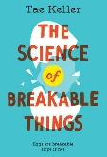  April 28 – May 29  23 Days | Investigating Innovation, Technology, & The Future  Floating Five: Strategic Reading Days (prior to FAST PM 3)  EQ: How does investigating and creating technology stimulate the imagination and encourage innovation and risk taking?  Anchor Texts: “Experimenting in Excellence” StudySync, Investigating Technology Text Set, Theme Park Design Text Set, The Science of Breakable Things  Writing Focus: Expository | Focus Benchmarks  ELA.6.R.1.1  ELA.6.R.1.2  ELA.6.R.1.3  ELA.6.R.2.1  ELA.6.R.2.2  ELA.6.R.2.3  ELA.6.R.2.4  ELA.6.R.3.1  ELA.6.R.3.4  ELA.6.C.1.2

Benchmarks ELA.6.V.1.2, ELA.6.V.1.3, and ELA.6.R.3.2 are embedded throughout each module.

